

American International University-Bangladesh (AIUB)  
**Department of Computer Science  
Faculty of Science &Technology (FST)  
Summer 20_21  
CSC 2210 Object Oriented Analysis and Design (OOAD)**

**Section: G  
Group No: 02**

**PROJECT TITLE: ONLINE BASED RESERVATION MANAGEMENT SYSTEM IN RAILWAYS**

An Object-Oriented Analysis and Design (OOAD) project submitted

By

|  |  |  |  |
| --- | --- | --- | --- |
| Serial No. | Student Name | Student ID | Contribution |
| 04 | SHAON, INDROJIT DHE | 18-38674-3 | 20% |
| 05 | PRANTO SAHA | 18-38805-3 | 20% |
| 06 | ABEDIN, MOHAMMAD ADNAN | 18-38821-3 | 20% |
| 10 | NABAJIT DEY | 19-40618-1 | 20% |
| 20 | TUNE, RIFAH NANZIBA | 20-42384-1 | 20% |

The project will be Evaluated for the following Course Outcomes

|  |  |
| --- | --- |
| **Project Marks Distribution** | Total Marks |
|  |
| Class Diagram and Sequence Diagram and [5Marks] |  |
| Activity Diagram [5Marks] |  |
| State Diagram [5Marks] |  |
| Submission, Completeness, Spelling, Grammar and Organization [5Marks] |  |

**Background Analysis of Our Project:**

Online based reservation management system in railways is an reservation system which is online based and where user can login to the user portal system by using their actual user id and password and book a rail (like international rail/metro rail/sub rail) tickets from anywhere in the world. Online based reservation system is now a useful and new addition to our daily life in public transport medium. It can be easier public's life. This system is a full fledge online based system and the most important part of the system is reserving tickets for travel, now in this project we are only concentrating on the following part.

Bangladesh is a densely populated country. People from all over the country uses public transport must. Many people to travel from home to their workstations and people has to spend their valuable time by waiting in line to get on a bus to go to work also because of the narrow roads and rickshaws traffic jam is meant to happen which doubles the stress and kills more time. As railway system is a essential addition to the public transport sector. So to remove the hassle of reserving tickets from physical stations and long waiting ticket lines, our project will help them on the process. People can sit on their house and reserve tickets to their respective destination at any given time and depart for their workstations with any hassle. They can enjoy their life.

**Solution Analysis of Our Project:**

Here, we include all types of railway services. This online based reservation management system will be both available on mobile application and open browsers, people can access to their user account to their accounts in both platform. All the user and system information will be stored in an internal database where people can get information about any railways related queries by one click. We already discussed about the background analysis of our project in the opening part now we are going to discuss about the depth solution. As the world is daily approaching to the peak of technological achievement, our country is trying its best by digitalization of its traditional systems and people are more into online based solutions to their problems rather than solving them offline. Our system is the best online based solution on following problem. By making an online based reservation management system for the public transport people will find easy to travel through public transport. As the whole solution is based on the convenience of the mass it has no business objectives and its sole reason is to make peoples life easier.

**Description of Class Diagram:** Class diagrams are the main building block of any object-oriented solution. It shows the classes in a system, attributes, and operations of each class and the relationship between each class.

In most modeling tools, a class has three parts. Name at the top, attributes in the middle and operations or methods at the bottom. In a large system with many related classes, classes are grouped together to create class diagrams. Different relationships between classes are shown by different types of arrows.

**Description of Sequence Diagram:** Sequence diagrams in UML show how objects interact with each other and the order those interactions occur. It’s important to note that they show the interactions for a particular scenario. The processes are represented vertically and interactions are shown as arrows. This article explains the purpose and the basics of Sequence diagrams.

**Description of Activity Diagram:** Activity diagrams represent workflows in a graphical way. They can be used to describe the business workflow or the operational workflow of any component in a system. Sometimes activity diagrams are used as an alternative to State machine diagrams.

**Description of State Diagram:** State diagrams are similar to activity diagrams, although notations and usage change a bit. They are sometimes known as  state machine diagrams or state chart diagrams as well. These are very useful to describe the behavior of objects that act differently according to the state they are in at the moment. The State machine diagram below shows the basic states and actions.

**Class Diagram– Scenario :**

In an online based reservation (booking) management system, a user logs in to the account with his valid user id and password, then the system checks if the given user id and password is valid or not. Then the user reserves ticket by filling information about his destination, and time. One user can book one or more tickets. The user can also get update of current position of the train and the system gives information with help of GPS tracking. After the ticket reserving, the user has to do payment for the ticket. The user can also register any kind of complain regarding ticket reservation and late arrival of train. A user can register one or more complains.

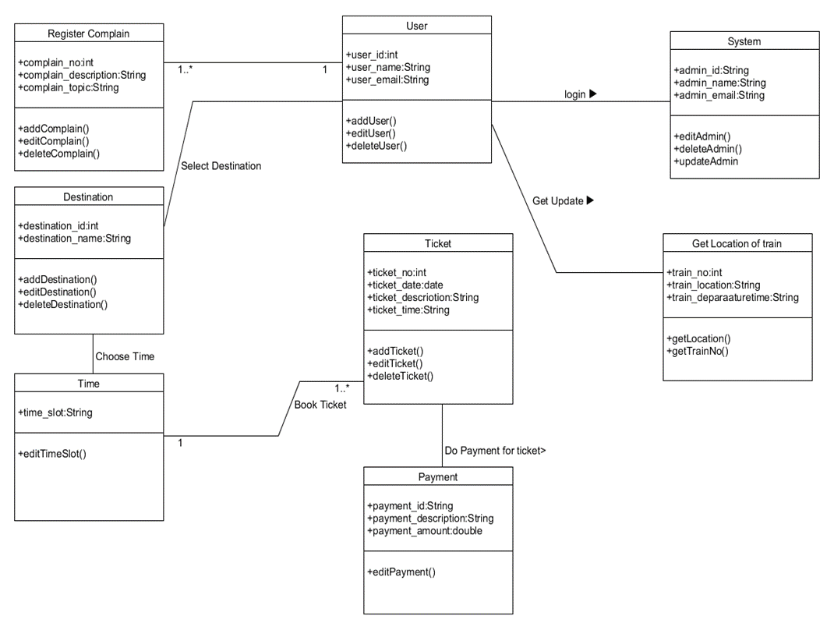

**Sequence Diagram- Scenario:**

When user logs in into the account to reserve a ticket the system checks in the database if the user is valid or not. If the user is valid and after filling all the information of reserving a ticket, the system checks in the database if the ticket on the specified time is available or not. If the ticket is available a reservation is generated and a notification with confirmation and ticket number is sent to the user. If the user is not valid the system notifies the user about invalid login information. And if the ticket is unavailable the user is notified by the system.

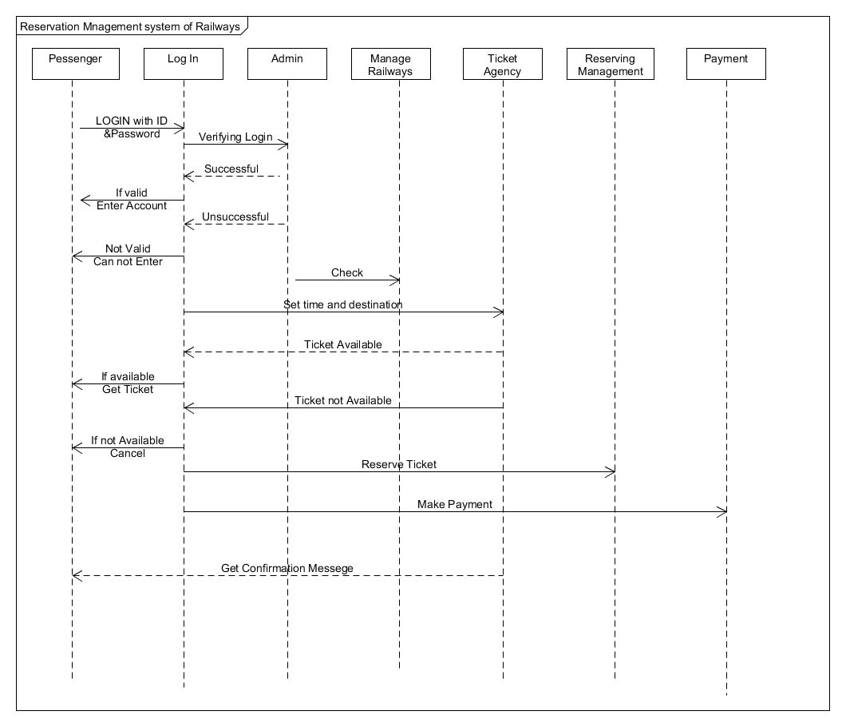

**Activity Diagram- Scenario:**

The user uses log-in id and password to log-in to the system. The system checks if the login id is valid or not if the information is valid the user has logged in the system successfully. Then the user selects the destination and time to reserve a ticket. Then the system checks if the ticket is available for certain time. If the ticket is available the user proceeds to make payment for the ticket otherwise the user has to request ticket for different time and date. After that the user can proceed to make payment. If the payment is successful the system sends notification to the user with confirmation and Ticket Number. If the payment is unsuccessful the user is requested to make the payment again.

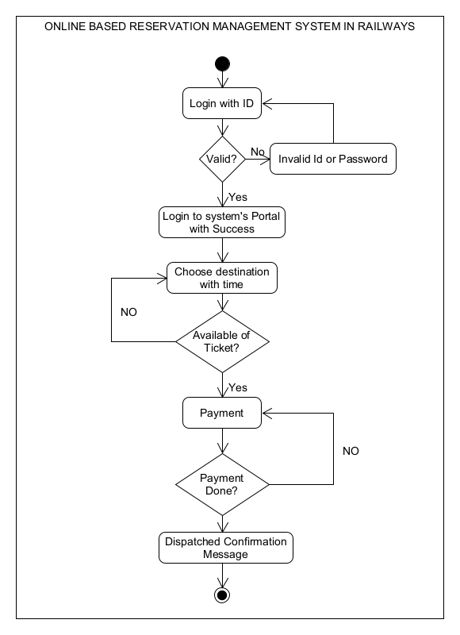

**State Diagram- Scenario:**

When user logs in into the account to reserve a ticket the system checks in the database if the user is valid or not. If the user is valid and after filling all the information of reserving a ticket, the system checks in the database if the ticket on the specified time is available or not. If the ticket is available a reservation is generated and a notification with confirmation and ticket number is sent to the user. If the user is not valid the system notifies the user about invalid login information. And if the ticket is unavailable the user is notified by the system.

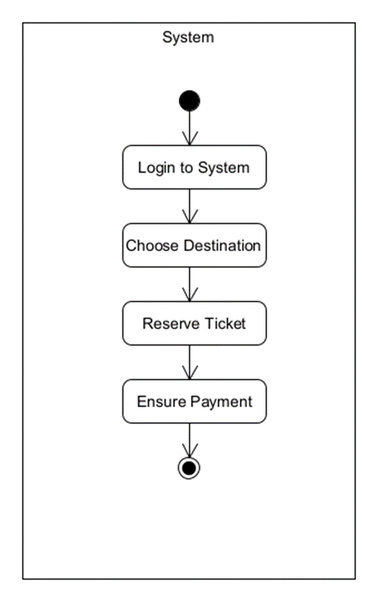

**Conclusion:**

The project is simple yet effective and essential. There are further scopes of upgrading and altering this system. Thereafter, the system can be changed according to requirements.

-THE END-